Helen Jaccard
Veterans For Peace
Golden Rule Project

Report on my first trip to Japan, December 2 - 21, 2017
I still need to add some pictures - and if you have some to share, please send them to vfpgoldenruleroject@gmail.com or helen.jaccard@gmail.com

Thank you!

Summary of my first trip to Japan:
The purpose of my trip to Japan was to prepare for the Golden Rule peace boat to sail to Japan and participate with the Japanese commemorating the 75th anniversary of the atomic bombings on Hiroshima and Nagasaki in August 2020.

I learned a lot about World War II, nuclear weapons, nuclear energy, and anti-nuclear, anti-war activism in Japan. My entire journey was meaningful and exciting. Everyone was very friendly, loving and welcoming.

I look forward to my next trip to Japan, November 14, 2018 for a university speaking tour and to further prepare for the Golden Rule’s arrival in 2020.

World War II and nuclear issues affecting Japan
Visited:
Center for Tokyo Raids and War Damage
Hiroshima and Nagasaki memorials
Lucky Dragon 5 museum
Fukushima
Listened:
Nanjing Massacre presentation
testimony from Fukushima evacuees
testimony and presentation by Dr. Ushiyama, children's thyroid cancer specialist
Testimony from 4 Hibakusha who survived the Hiroshima bomb
Discussions of nuclear energy and the US - Japan nuclear agreement

Gave 10 public presentations:
Fukushima Waseda University in Tokyo
Yokohama Kanagawa
Shensu University in Tokyo Ehime University (2)
Hiroshima (2) Kyoto

Participated in 7 meetings to discuss Golden Rule arrival in Japan
Peace Boat
Research Center for Nuclear Weapons Abolition at Nagasaki University
World Friendship Center in Hiroshima
Prof. Kazuyo Yamane of International Peace Museums
Tekiguchi Tatsuo, Nagasaki activist
Joe Essertier, Nagoya activist
Moriguchi Mitsugi, Nagasaki Atomic-Bomb Testimony Society

Most people saw the PowerPoint presentation, one or two at a time so they could understand the nature of the project.

Details and pictures of my first visit to Japan

The very busy, meaningful trip started my first day, December 3.
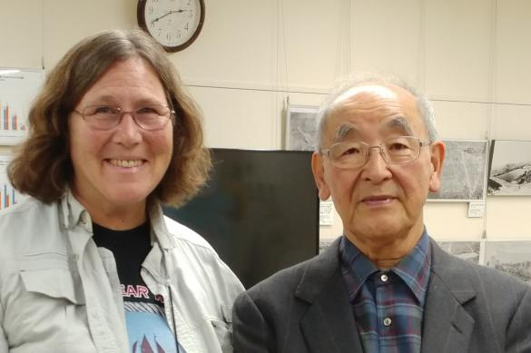
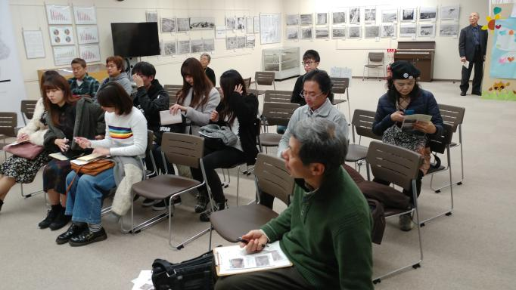
Shiraishi Tetsuzo
Survivor of Tokyo napalm bomb raid

I was accompanied by Masato Nakamura, Yuri Kadoya-Ogata and Prof. Takao Takahara, his six students and interpreter Rosemary Soliman to the Center of the Tokyo Raids and War Damage. Mr. Shiraishi Tetsuzo, Survivor of the napalm bombing of Tokyo shared his story.

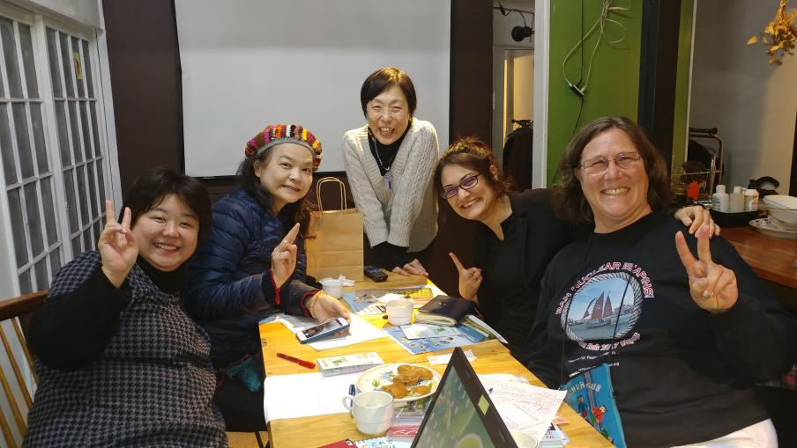
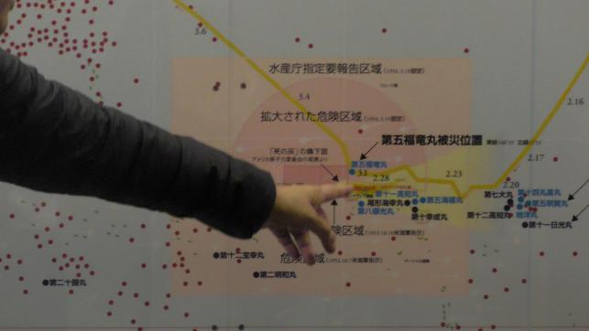
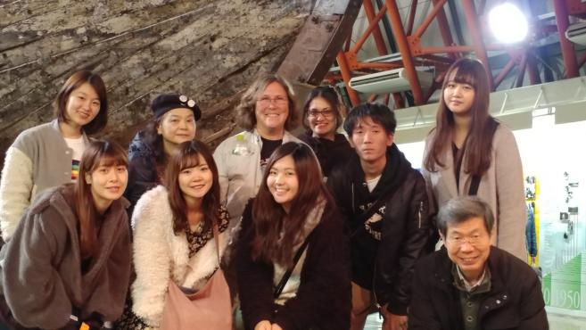
We also visited the Daigo Fukuryū Maru (Lucky Dragon 5) museum, home of the tuna fishing boat that was exposed to the Castle Bravo nuclear test radiation on March 1, 1954. Finally, we saw the Fish Market and the location where the radioactive fish were first buried.
Naoko Suzuki, Yuri Kadoya-Ogata, Hitomi Kamanaka, Rosemary Soliman and Helen Jaccard

The next day, Yuri, Naoko Suzuki, Rosemary and I visited Hitomi Kamanaka, the famous anti-nuclear film maker to plan our presentation for December 12 - and of course, plan how to save the world from nuclear madness.

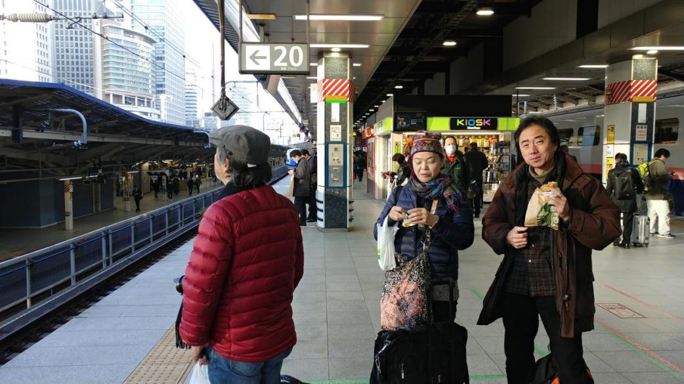
Mera, Yuri and Masato at the train station

On December 5-6 Masato, Yuri Kadoya-Ogata, Hanayo Oyo and Mera Seijiro accompanied me by bullitt train to Fukushima.

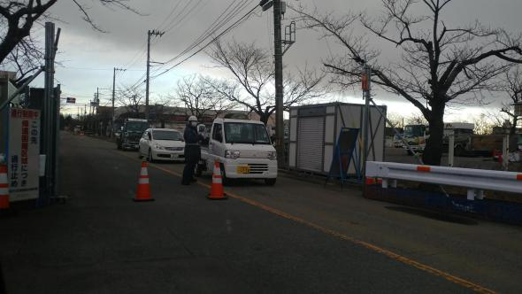
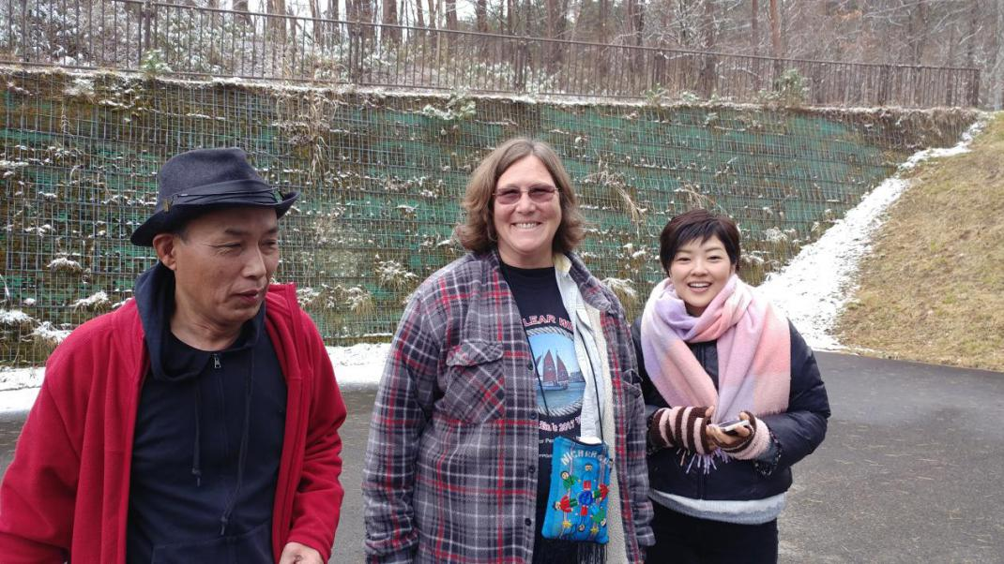
Sumio Konno, Helen Jaccard and Hanayo Oyo at the hot springs

Sumio Konno showed us the abandoned homes and farms,
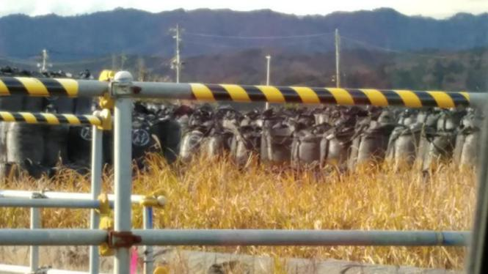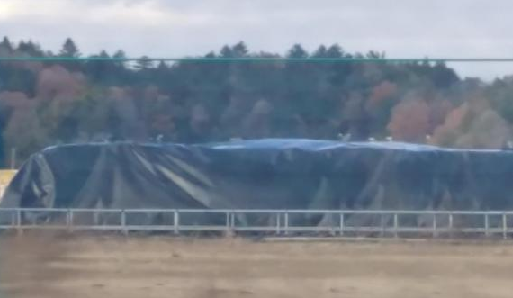
the miles of bags of radioactive debris,

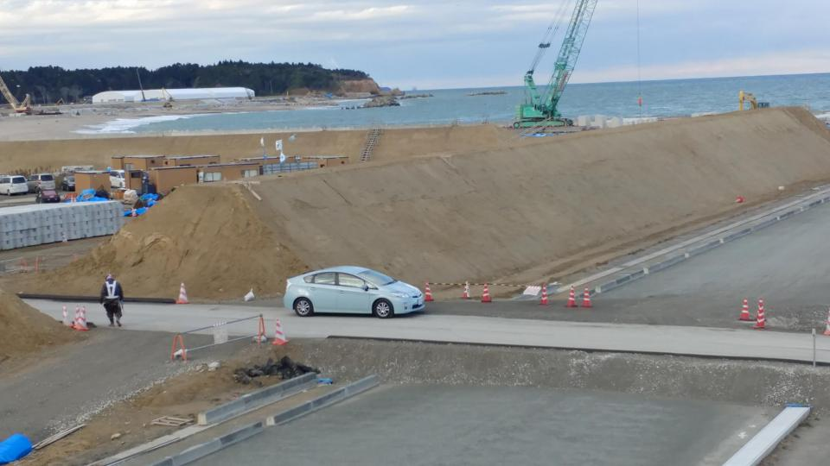
the sea wall made from contaminated dirt,

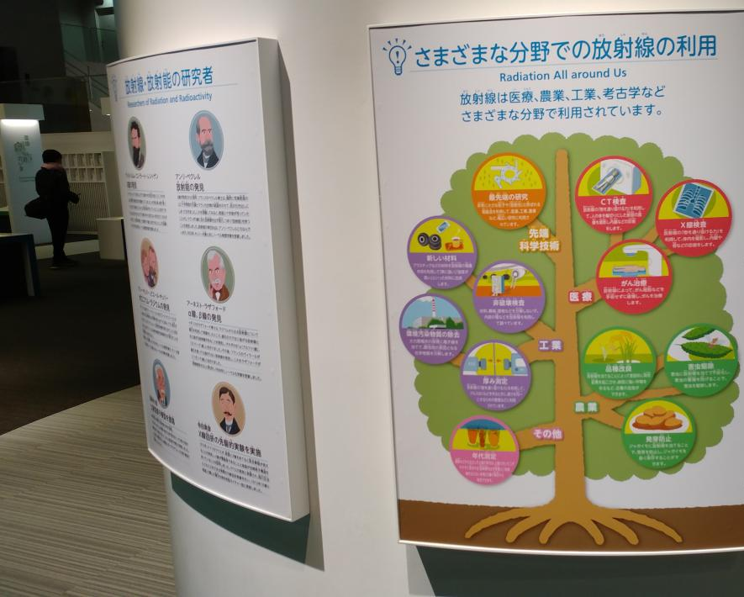
and the “Fukushima is fine” propaganda center.

He also took us to his abandoned home and neighborhood, just as it was left in March 2011. It will never be habitable again, being only 15 km from the nuclear power plant disaster.

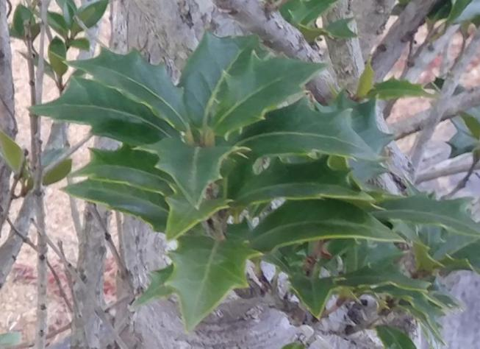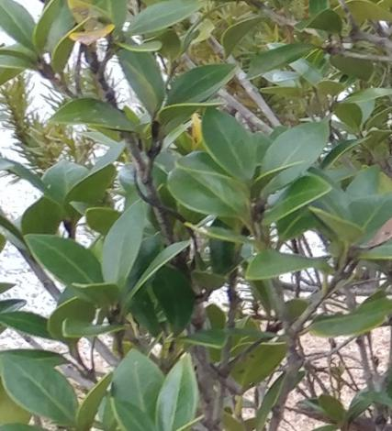
In his yard is a plant where some branches have mutated. It is only supposed to have serrated leaves, but some of the branches grow smooth leaves now.

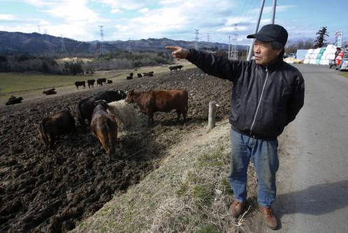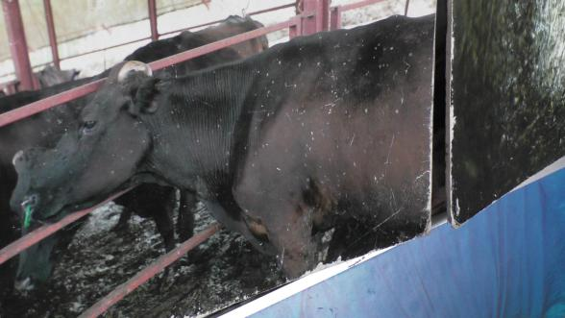
We had a very interesting visit with Masami Yoshizawa, a cowboy who refuses to kill or abandon his cattle - "I am a cowboy, and cowboys do not abandon their cows. I will stay with them until I die." and much more! He showed us pictures of cows with white spots due to radiation damage. The government has ordered him to kill his cows, and that just makes him mad.

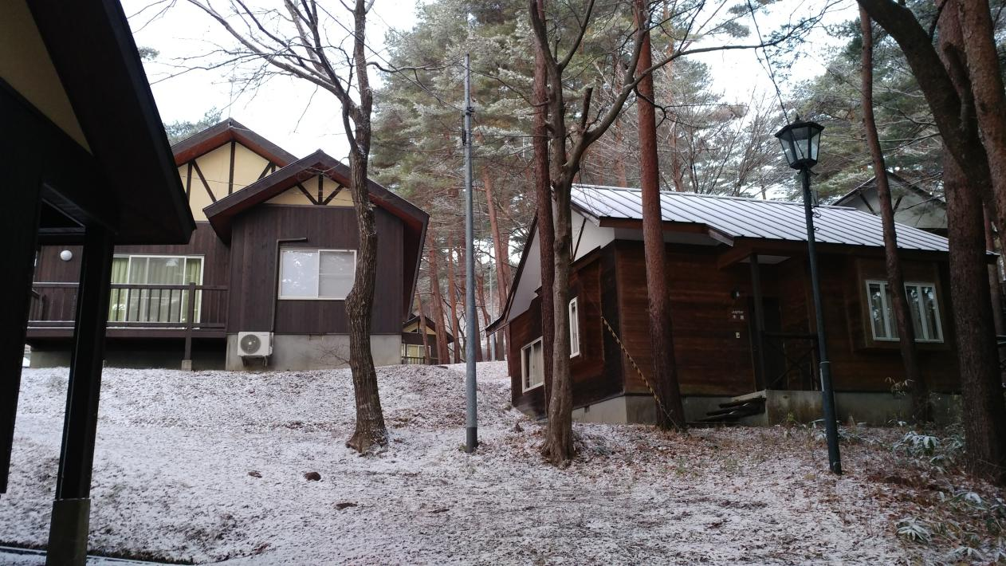
We stayed in a lovely cabin and went in a hot springs, Japanese style.

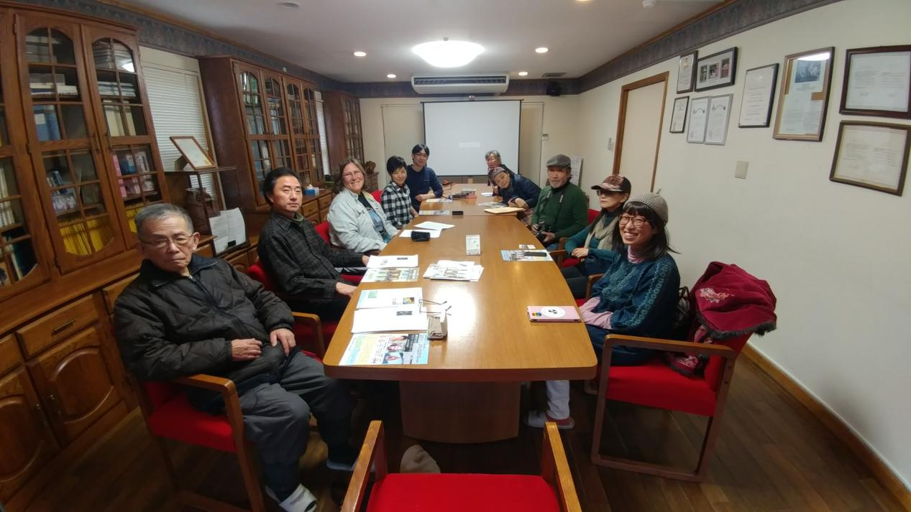A small group of us gathered at to talk with Ruiko Mutoh about the Golden Rule and The Complaintants for Criminal Prosecution of the Fukushima Nuclear Disaster - I learned SO MUCH! Thank you, Ruiko!

I gave my first presentation December 7 to twenty journalism students at Waseda University, with the help of co-presenter Hanayo Oyo. They asked me really great questions for over two hours!

I spent two nights with Joe and Yukari Essertier in Nagoya - they took me to a protest against the US military bases in Okinawa and a presentation about the Nanjing masacre. Joe is the Japan Rep of World Beyond War. Wow! What wonderful hosts they are, rolling out a mat in their small studio apartment - and keeping me well fed.

Rachel Clark joined me in Nagoya and we traveled to Shin Yokohama for a couple of nights. On December 11th, we traveled to Yokohama where an event was organized by Rachel's friends among Peace Boat passengers and Shigeru Nakagawa of VFPJ.

At Kanagawa Prefecture Civic Center, about 30 concerned citizens gathered and listened to my presentation. Mr. Hiroo Kubo of the Article 9 Society added a thorough explanation on the Trident Nuclear Missile system when I referred to the Golden Rule’s action at Naval Submarine Base Bangor in Washington State. They suggested that in 2020 the Golden Rule stop at Yokosuka Port, where they have a monthly vigil and peace march.

Have you ever met a whistle blower whose story still needs to be told? Dr. Motomi Ushiyama specializes in childhood cancer in children. Naoko Suzuki is mother of two daughters and evacuee from Fukushima who arranged this precious meeting with Dr. Ushiyama. Rachel, Naoko, Yuri and I met with Dr. Ushiyama on December 12. She told us how the Japan government’s study and treatment program has deprived those who were under five years old at the time of the Fukushima disaster a chance for thyroid screening and treatments. The younger you are, the more problems you have from radiation exposure! The study is completely hiding the reality of the high numbers of child thyroid cancers and the aggressive nature of cancers caused by radiation compared to cancers that occur for other reasons.

Rachel, Masato and I then visited Peace Boat's headquarters. Thanks to Meri Joyce of Peace Boat, the meeting with Shinsaku Nohira and Nancy Roberts was very fruitful in terms of finding possibilities of future collaboration between two Peace Boats--Golden Rule (the original Peace Boat) and the current Peace Boat during the summer of 2020.

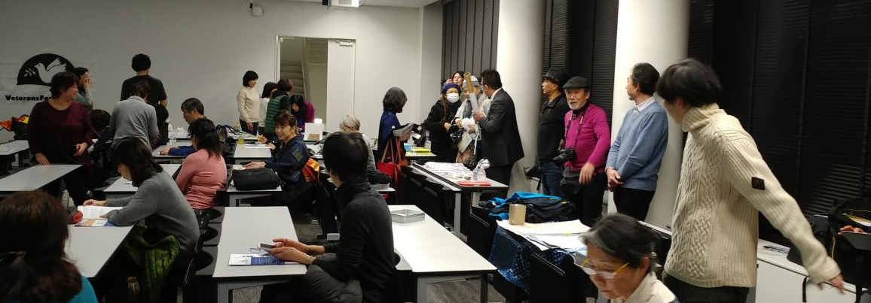
That same evening was a big, well publicized presentation featuring Hitomi Kamanaka, Naoko Suzuki and the Golden Rule at Senshu University, organized by Prof. Hiroshi Hasegawa. A newly translated documentary film of Phoenix of Hiroshima and Hitomi's short film on a female veteran who suffers from radiation were viewed, followed by a PowerPoint presentation which was the amalgamate of three panels' presentations.

December 14 I gave two presentations at Ehime University, arranged by our host Junko Abe.

Then it was on to Hiroshima and the World Friendship Center, founded by Barbara Reynolds of the Phoenix of Hiroshima. Masato joined Rachel and I, and I gave a presentation organized by WFC and their board members about the Phoenix and the Golden Rule, including showing the film, “The Phoenix of Hiroshima, A Voyage Interrupted”, by Brian Cowden.

Barbara Reynold's husband, Dr. Earle Reynolds was a researcher on the effects of radiation on children. The Reynolds family took off to a global sailing trip on a yacht called Phoenix of Hiroshima and happened to observe Golden Rule's trial in Honolulu. Inspired by the Golden Rule’s crew, who tried to stop nuclear tests in Marshall Islands, the Reynolds family sailed the Phoenix into the off-limit area of Marshall Islands. Ultimately, their stories became a part of propelling power of anti-nuclear movement and, in 1963, the U.S., UK, and USSR sighed the Limited Test Ban Treaty. This amazing story which connects dots of atomic bombs, nuclear tests in Marshall Islands, Lucky Dragon, Golden Rule, Phoenix of Hiroshima is so inspiring and future-oriented that people outside nuclear activists can be attracted. When Golden Rule comes to Japan in 2020, it needs massive supporters across Japan. For that, WFC in Hiroshima could play a major role in Hiroshima.

Rachel, Masato and I visited the Hiroshima Peace Memorial Museum. That evening, at the Social Book Cafe Hachidori-sha, I gave a presentation together with the Phoenix of Hiroshima film. NHK (Japanese version of NPR) crew came and filmed my presentation, and interviewed me, thanks to VFPJ Hiroshima team, Erika Abiko (who owns the cafe) and Ken'ichi Narikawa. NHK has since been in touch with me about their article, which will be published the last week of January.

On December 17, Masato, Rachel and I traveled to Osaka and met up with Yoshiko Tanigawa, who organized a series of events and meetings for us, and offered amazing hospitality of her home to us. Thanks to the efforts of “Helen Team Kyoto”, a huge article was published in Kyoto Shimbun newspaper even before my arrival at Kyoto!

In the morning of December 18, thanks to Yoshiko, Mami Kurumada, a member of "Thanks and Dream," a group of evacuees from Fukushima, explained the situation of families divided since the nuclear disaster. In her case, she and her children have been living in Kyoto, and her husband visits them on twice-a-month basis. Although some people’s homes are not necessarily in the evacuation zone, many houses in Fukushima are too contaminated with radiation for people to live in. They may never be safe, even after decontamination, especially for small children, and especially for girls. Girls are more vulnerable to the effects of radiation. 20mSv/year is the maximum radiation level set by the Japanese government now, but it is not a safe limit. It had been 1mSv/year and was elevated to 20mSv/year by a governmental decision just for the sake of keeping local residents in their contaminated homes. The Government of Japan (GOJ) used to provide subsidies for voluntary evacuees but stopped it at the end of March 2017, for the above reason. They even publicly announced that they would reduce evacuees down to zero by 2020 Olympic Games, whereas evacuees are suing GOJ and TEPCO for their right to choose their place to live. I had a quality interview with Mami, especially after our meeting with Dr. Ushiyama. These series of meeting arrangements were so significant that Rachel and I were able to gain in-depth comprehension of the radiation ramifications and the importance of the GOJ deceptions and manipulations.

After the morning meeting with Mami, Yoshiko took Rachel and I to the Hitomachi Civic Center in Kyoto, where we met Ms. Akiko Morimatsu, a leader of "Thanks and Dream" who is also in charge of their law suit against GOJ, followed by a small party exchanging among visitors and seven members of “Team Helen Kyoto”. It was a WONDERFUL party and I received so many incredible gifts! THANK YOU! Ms. Yoshiko Tanigawa of the Kyoto Museum for World Peace at Ritsumeikan University, Ms. Kobayashi, Ms. Yameda, Ms. Rumi Hanagaki, who survived the Hiroshima bomb at age 5, Yoshiko Suzuki of the World Peace Museum, Mami, Masato, Rachel, Helen, and Hitomi Katayama of Mayors for Peace and the anti-nuclear film maker.

After the party on December 18, Then Masato, Rachel and I were brought to the event venue where we met more supporters in Kyoto, VFPJ Kyoto team, and a full venue. Here, too, the Phoenix film viewing and my lecture was warmly welcomed. The event ended with singing "We shall Overcome" together among all the participants. Team Helen's new Japanese version lyric was a master piece. Code Pink Osaka was there and gave a big “Hello” to Gerry Condon, who had met them at the Peace & Planet conference in New York in 2015 before the NPT review.

On December 19, Helen, Masato, Yoshiko, and Rachel visited Kyoto Museum for World Peace where Yoshiko and some of Team Helen members devote themselves there as volunteer guides. This museum is incorporated with Ritsumeikan University, one of whose faculty, Prof. Kazuyo Yamane is highly regarded in international peace museum field. Being a historic town and a candidate for dropping the atomic bomb, city of Kyoto was well preserved and so were many war related goods in good condition. Owners donated them to the museum in order to exhibit the evidence of the government propaganda which propelled and emotionally controlled young students and made them sacrifice their lives for the war certain to lose. It would be extremely beneficial for any VFP members who visit Kyoto to consider that visiting this museum is as prerequisite as visiting peace museums in Hiroshima, Nagasaki, and Tokyo Air Raid Museum.

Prof. Kazuyo Yamane came to see them and took them to a nice lunch, where Helen were able to explain the Golden Rule Project. Dr. Yamane expressed her strong interest in inviting Helen to her class in Fall, 2018.

After the lunch meeting, we returned to the museum where we met Ms. Rumi Hanagami, an A-bomb survivor in Hiroshima and a story teller. Rumi performed her "Kamishibai," a traditional story telling with picture cards. This is the way Ms. Hanagami conveys her message of peace to children, even though their understanding on nuclear issues are still limited.

Then I had an interview by a Mr. Shotaro “Sho” Asano, a reporter with Mainichi Channel 145, followed by group photos. Then we left Kyoto for our final destination, Nagasaki.

On December 20, Rachel and I visited the Nagasaki Atomic Bomb Museum, followed by a meeting with Mr. Tatsuo Sekiguchi, video journalist and former newscaster of Nagasaki Broadcasting, and Mr. Mitsugi Moriguchi of Nagasaki Atomic-Bomb Testimony Society. During this short meeting, Mr. Moriguchi decided to recommend me as a guest speaker to the committee of a peace event in Nagasaki planned this coming November, which means that I would have a good chance to be invited to Nagasaki and Kyoto. If those plans materialize, I will approach college campuses in Tokyo and Nagoya, too, through Masato, VFPJ. In order to maximize her 3 weeks JR pass, I will approach other major cities with ports along Japan's coastline, so that I can cultivate ports of call in 2020.

Mr. Moriguchi was so kind that he gave Rachel and I a ride to RECNA - Research Center for Nuclear Weapons Abolition at Nagasaki University, where we met with Prof. Tatsujiro Suzuki, Director and Prof. Keiko Nakamura, champion of nuclear disarmament and part of the United Nations NGO community.

We had a very in-depth discussion about both nuclear energy and nuclear weapons as well as the 46 tons of plutonium that Japan has acquired from its nuclear power plants. I hope I will be invited by Nagasaki University to speak in November, 2018.

Thank you everyone for this meaningful visit! I look forward to seeing you all again soon!

Helen Jaccard

Sailing for a nuclear-free world!

VFP Golden Rule Project Manager
+1 206-992-6364
vfpgoldenruleproject@gmail.com
Vfpgoldenruleproject.org
Facebook: GoldenRulePeaceBoat

