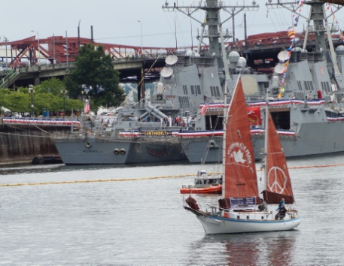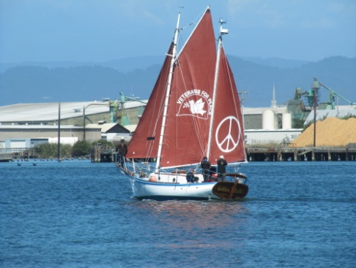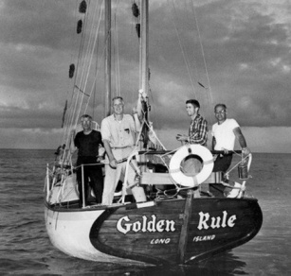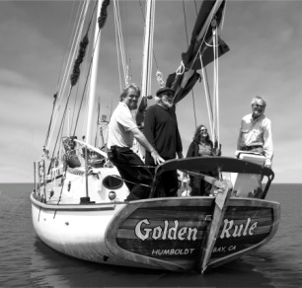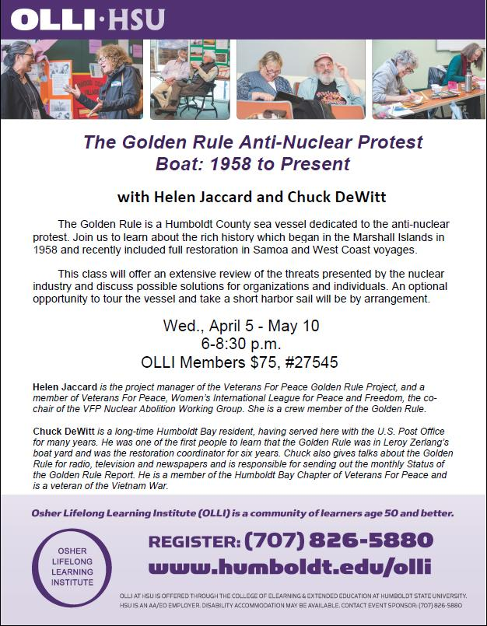

***The Golden Rule Peace Boat: 1958 to Present***

***Sailing for a Nuclear-Free World!***

The Golden Rule is a Humboldt County sailing ketch originally used to protest against nuclear weapons testing. She sails again to promote a nuclear-free future, to educate about the dangers of radiation to humanity and the environment, and to support peaceful alternatives to war.   
Learn of the *Golden Rule’s* remarkable history, including antinuclear protests in 1958, and how, after sinking in Humboldt Bay, she was restored by local veterans, Quakers and “boat people.”

The six unique classes offer an extensive review of the threats presented by the nuclear buildup and the nuclear industry today. Learn how YOU can influence public opinion and policy-makers in order to stop the possibility of nuclear war, and convert to carbon-free, nuclear-free energy.

**Wednesdays, April 5 - May 10, 6 pm - 8:30 pm  
OLLI Members $75, Non-members $100, Course #27545**

**FILMS! DISCUSSION! GUEST SPEAKERS! DEBATE! TOUR THE BOAT! GO SAILING?**

**INSTRUCTORS:**

**Helen Jaccard,** VFP Golden Rule Project Manager

**Chuck DeWitt,** Restoration Coordinator and member of Humboldt Bay Veterans For Peace

**Questions about the course? Want to volunteer as a guest speaker?  
Please call Helen Jaccard at 206-992-6364***The Golden Rule is a national project of Veterans For Peace (VFP), a nonprofit organization  
with chapters in over 100 cities, including VFP Chapter 56 in Humboldt Bay.*